

Breakdown: 14% Daily Grade

35% Summative Assessment 11% Homework

25% Formative Assessment 15% Review / Practice

Plot

Character

Vocabulary

Dramatic Reading

Wednesday Writing

Grammar & Usage

|  |
| --- |
| Narrator & Voice |
| Setting |

syllabus

mr. flamm: English one

Room 329

leonardo di caprio as romeo

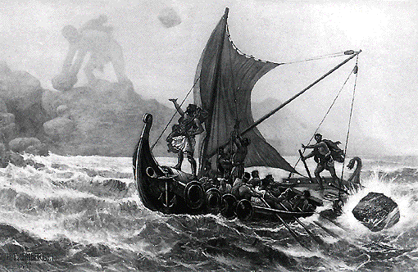

*Mythology*

*The Odyssey*

*Romeo & Juliet*

Non-Traditional Texts

The Graphic Novel

First Marking Period:

Fall 2016

Instructor: Mr. Flamm Email: [icflamm@sof.philasd.org](mailto:icflamm@sof.philasd.org) Website: mrflamm.com



Grammar & Usage

Vocabulary

Irony & Ambiguity

Discussion

Poetry

Drama

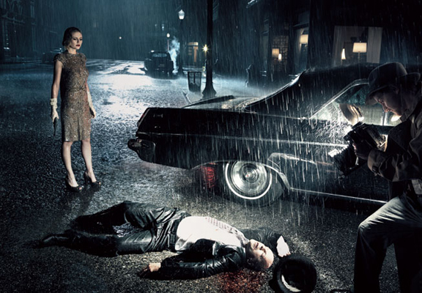

Second Marking Period:



Providing Examples from the text

Mr. F Podcast

Third and Fourth Marking Periods

HEADER

SUBHEAD HERE

ENTER Month/year

Insert Text or Logo here.

Delete this box or enter quote or tagline here.

HEADER/logo

SUBHEAD HERE